Power System Modeling for Control Purposes

EE 5805 Directed Study in Electrical and Coputer Engineering, Spring 2024

*Jerome Cordjotse*

# Introduction

Microgrids, small-scale power generation, and storage technologies are examples of distributed power systems that are often used to supplement or improve traditional electric power systems. These systems are not the same as the large-scale, centralized power systems found in traditional power plants. Distributed power systems are situated near the load they service and are modular and flexible, in contrast to traditional centralized power plants. These systems can also function independently or be connected to the grid.

The N-bus system is studied and used to determine the power input's operating points inside the power system's dynamic model. Each bus is characterized by voltage, phase angle, and power injections. N-Bus modeling reflects power network topology, aiding in power flow, voltage regulation, and stability analysis, optimizing performance[]. The Y-bus matrix, derived from system parameters, models impedance and admittance between buses, vital for load flow and fault analysis[].

Power generation is model using a Differential-Algebraic Equations which combines the admittance matrix $Y_{bus}$ in the ohm’s law $I=YV$ and the generator dynamic equation known as Swing Equation” $J\dot{ω}=T_{e}-T_{m}-Dwω$.

# Modeling

## Simple N-Bus System

The two-bus system in figure 1 demonstrates how model the power system network of two buses with line impedance and impedance to ground.

Figure 1: Two-Bus System

The Admittance matrix can be derived in form:

$$\left[\begin{matrix}y10+y12 & -y12 \\ -y12 & y12+y20\end{matrix}\right]=\left[\begin{matrix}Y11 & Y12 \\ Y12 & Y22\end{matrix}\right]$$

Where $y_{nm}$ is admittance of a line from $n$ to $m$, with $0$, signifying ground. The Ohm’s law equation becomes:

|  |  |
| --- | --- |
| $$\left[\begin{matrix}I1 \\ I2\end{matrix}\right]=\left[\begin{matrix}Y11 & Y12 \\ Y12 & Y22\end{matrix}\right]\left[\begin{matrix}V1 \\ V2\end{matrix}\right]$$ | (1) |

Where $In$ is the injected current into bus and $Vn$ is voltage at bus $n$.

## Power Flow

To determine power flow from figure 2, the equation (2) is used.

Figure 2: N-Bus System with power injection.

The power equation, $S=P+jQ=VI^{*}$ where

|  |  |  |
| --- | --- | --- |
|  |  | (2) |

## Generator Model

Adding Generator $G_{1}$, to figure 1 give a schematic in figure 3. No power is injected in bus 2, while the line impedance $y_{10}$, from bus 1 to ground is infinite .

Figure 3: Two-Bus System with Generator at Bus 1

The voltage at bus one is known since this is the bus with the generation. The unknowns become $I_{1}$, and $V_{2}$, where $V_{2}=f(\left|V_{2}\right|,δ_{2})$

|  |  |
| --- | --- |
| $$\left[\begin{matrix}I1 \\ 0\end{matrix}\right]=\left[\begin{matrix}y12 & -y12 \\ -y12 & y20+y12\end{matrix}\right]\left[\begin{matrix}V1 \\ V2\end{matrix}\right]$$ | (3) |

The Generator can be model with dynamics with its inertia $J$ from figure 4. This represents a swing equation (4).

Figure 4: Generator as an Inertia Dynamic System

|  |  |
| --- | --- |
| $$J\dot{ω}=T_{m}-\frac{P_{e}}{ω}-bω$$ | (4) |

Where $P_{e}=\left|V_{1}\right|\left|I_{1}\right|cos(δ_{1})$. $\left|V_{1}\right|,\left|I_{1}\right| and δ_{1}$, are solved from the equation (3).

## Nine-bus System

The Nine-Bus System is a benchmark test case used in analysis to model a three-phase power system network made up of nine buses, or nodes, generators, loads, transformers, and transmission lines is modeled.

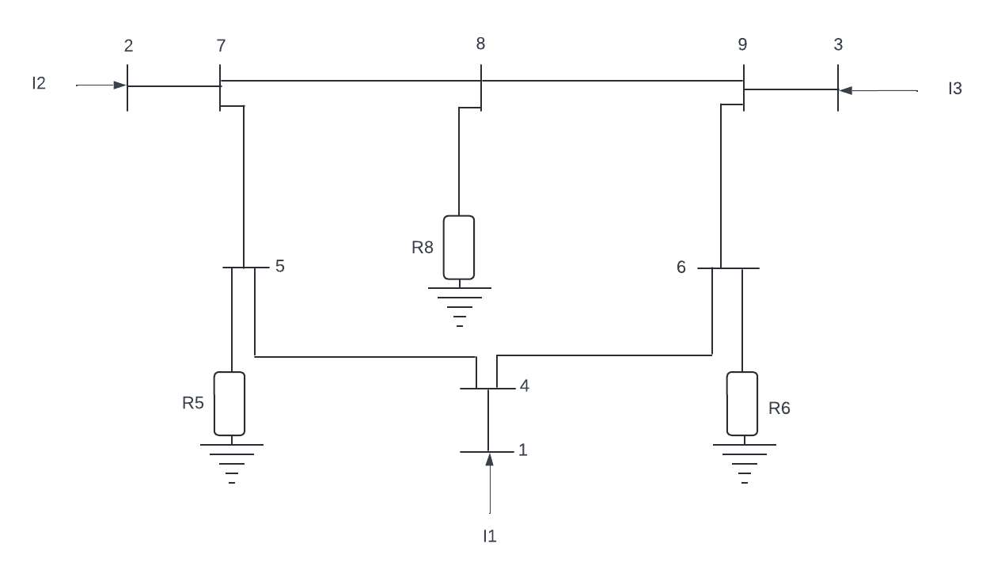

Figure 5: Nine-Bus Power System

The nine-bus system’s Ybus was generated in ma was model into practice generating large equations. The final goal was to generate the Differenial-Algebraic model of the nine-bus system for further test.

## Final Model

To generate the final model, the swing equation was expanded upon. The equation (4) in power networks that have many synchronous machines running simultaneously must account for the changing angular velocity relative to the other system. The relative positions of the rotor axis and the resulting magnetic field axis are fixed under typical operating conditions. The rotor angle is the angle created by the rotor axis’ relative motion in a synchronous machine. This motion reacts to disturbances in the synchronously rotating air gap and is initiated by the machine's acceleration or deceleration. This motion is quantified by the non-linear second-order differential equation known as the swing equation. The power transfer that results from rotor swing, either acceleration or deceleration, between the mechanical rotor and the electrical grid is known as inertial response.

The final Differential Algebraic Equation model combining (3) and (4):

|  |  |
| --- | --- |
|  | (4) |

# Simulation

## Ybus Generator

The control method proposed for this paper is to split the control into a cascaded controller for improved state response a robustness to parametrization. The outer loop controls the angular position which uses the Feedback Linearization technique for generating a control law for position with input torque and the inner loop for current tracking as shown in Figure.

## Steady State Solver

## Simulink ODE

Defining the nonlinear system in the form, $\dot{x}\left(t\right)=f\left(x,u\right)$, helps to implement the input-output linearization technique. The form is below:

|  |  |  |
| --- | --- | --- |
|  | $$\dot{x}\left(t\right)=f\left(x\right)+g\left(x\right)u, y=h(x)$$ | (5) |

# Results

Before you begin to format your paper, first write and save the content as a separate text file. Keep your text and graphic files separate until after the text has been formatted and styled. Do not use hard tabs, and limit use of hard returns to only one return at the end of a paragraph. Do not add any kind of pagination anywhere in the paper. Do not number text heads-the template will do that

##### References

1. G. Eason, B. Noble, and I. N. Sneddon, “On certain integrals of Lipschitz-Hankel type involving products of Bessel functions,” Phil. Trans. Roy. Soc. London, vol. A247, pp. 529–551, April 1955. *(references)*
2. Zhang, S., Gu, W., Hu, Y., Du, J., & Chen, H. (2016, July). Angular speed control of brushed DC motor using nonlinear method: Design and experiment. In 2016 35th Chinese Control Conference (CCC) (pp. 1045-1050). IEEE.
3. Peng, J., & Dubay, R. (2011). Identification and adaptive neural network control of a DC motor system with dead-zone characteristics. ISA transactions, 50(4), 588-598.
4. T. Kara and I. Eker, "Nonlinear modeling and identification of a DC motor for bidirectional operation with real time experiments," Energy Conversion and Management, vol. 45, no. 7-8, pp. 1087-1106, 2004. Analysis and Control of Nonlinear DC Motor Coupled with Inverted Pendulum - EE 6702 Jerome Cordjotse MS ECE 8
5. Valenzuela, M. A., Bentley, J. M., & Lorenz, R. D. (2005). Evaluation of torsional oscillations in paper machine sections. IEEE Transactions on Industry Applications, 41(2), 493- 501.
6. J. Herníndez-Santiago, J. Garrido-Meléndez, B. A. Escobedo-Trujillo, and G. Alcalá-Peréa, "Exact Feedback Linearization Technique Applied to an Inverted Pendulum Coupled to a DC Motor," in 2023 IEEE International Conference on Engineering Veracruz (ICEV), 2023: IEEE, pp. 1-6.
7. R.-H. Wu and P.-C. Tung, "Studies of stick-slip friction, presliding displacement, and hunting," J. Dyn. Sys., Meas., Control, vol. 124, no. 1, pp. 111-117, 2002.
8. CAD Cascaded